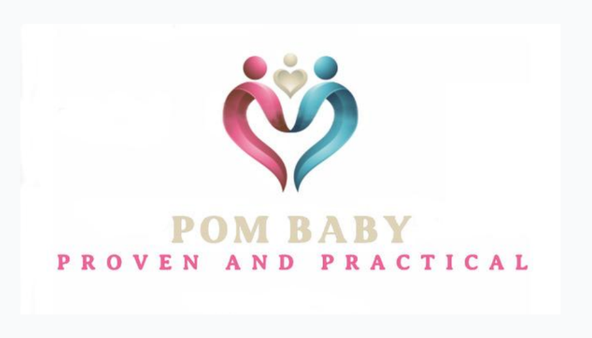

Breastfeeding Café Fee/Attendance Information: 3 months = 12 Calendar weeks

First Class Can attend any/all sessions through:
January 5, 2026 March 23, 2026
January 12th 2026 March 30, 2026
January 19, 2026 April 6, 2026
January 26, 2026 April 13, 2026
February 2, 2026 April 20, 2026
February 9, 2026 April 27, 2026
February 16, 2026 May 4, 2026
February 23, 2026 May 11, 2026
March 2, 2026 May 18, 2026
March 9, 2026 May 25, 2026
March 16, 2026 June 1, 2026
March 23, 2026 June 8, 2026
March 30, 2026 June 15, 2026
April 6, 2026 June 22, 2026
April 13, 2026 June 29, 2026
April 20, 2026 July 6, 2026

